May 24th, 2009
Hi
Not much to write about. I did not do any exercise at all last week – just too tired.
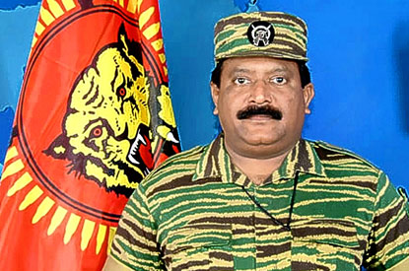
Well, the Sri Lankan civil war appears to be over after about 25 years, according to the Sri Lankan government. The Tamil Tigers were certainly a brutal lot (leader in photo). After all, they initiated the use of suicide bombers and according to reports, child soldiers (though I would not be surprised if child soldiers have been used elsewhere before that, such as in Africa, and probably in centuries past). However, the Sri Lankan Army were no angels either! Gavin says he finds himself sympathetic to the plight of the Tamils, and I agree with him. The roots of the trouble go back to colonial times, when the British tended to favour the minority Tamils (mainly Hindus), at the expense of the Sinhalese majority (mainly Buddhists) for jobs on the Civil Service, etc. – the old ‘divide and rule’ policy. When independence was obtained in 1948, the Tamils suffered for many reasons, such as:
- Sinhalese was made the sole official language and so many Tamil civil servants, who could not speak the language, had to resign.
- Attempts were made to make Buddhism the official religion
- Affirmative action, in favour of the Sinhalese to reverse colonial discrimination against Shinhalese in favour of Tamil. (Cf. the similar laws in Malaysia – announced this past week, by the way, to be repealed.)
As a result, many Tamil, in response to these deliberate marginalisations, came to believe that they deserved a separate nation state for themselves.

On Tuesday, I went to the dermatology clinic again. There was another new person, which is irritating, as it’s a bit like ‘Snakes and ladders’ having to go back and explain all that has happened in the past, even though some of this is written in my file. Anyway, it seems that he might be a bit better than the previous guy.
In the UK, the government finally gave in to almost universal support in the country and passes laws allowing pre-1997 Ghurkhas and their families the right to live in the UK. Post-1997 Ghurkhas had been given this right earlier. As Ghurkhas have been fighting in the British army for about 200 years, I think it is about time! Did I tell you that Prem, the Nepalese guy (not a Ghurkha), whose father was in the British Army in HK, has UK citizenship and after leaving here, is probably now in the UK?

In NZ recently, a couple who owned a small business asked Westpac bank for a NZ$10 000 loan. The person who approved the loan accidently added three zeros to the amount deposited in their account. The couple then took off with the money. Interpol was informed and a radio report yesterday suggests that they are in HK.
More swine flu cases are cropping up in HK. The total now is 6 and all but one have been imported from the US, with CX 831 featuring prominently in bringing the virus to HK (and to other places by passengers transiting through HK).
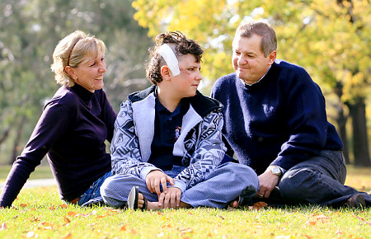
Did you hear about the unusual surgery in a small rural town in Australia? A 12-year-old boy had received a head injury when he fell off his bike. At the local hospital, the doctor realised that the swelling from blood was building up fast in his brain and was likely to kill the boy within minutes unless the pressure was relieved. (This was the same deadly condition that recently claimed the life of actress Natasha Richardson, wife of actor Liam Neeson.) Unfortunately, the hospital did not have the instruments needed to do this. So he got a power tool drill from a hospital maintenance room and bored a hole in the boy’s head with it. It worked!
That seems to be it for now.
Cheers

